TASK 5: IMPLEMENTATION OF BOOK MODEL AND REPOSITORY
Project Title: Dockerized Book Issue and Return System
Name: Swar Sawalkar
Roll No.: 23104B0023
Department: CMPN – 4th Year
Division: C

1. Aim
To implement the Book model and repository using Java, Spring Boot, and Spring Data JPA for storing and retrieving book information in the Book Issue and Return System.
2. Objectives
- To create a Book entity representing book records.
- To map Java objects to database records using JPA.
- To implement a repository for database operations.
- To understand the role of entities and repositories in Spring Boot.
- To verify the implementation through compilation and testing.
3. Software and Technologies Used
Technology | Purpose
Java 21 | Implementing the Book model
Spring Boot | Application framework
Spring Data JPA | Database access
Hibernate | Object-relational mapping
Maven | Compilation and dependency management
MySQL | Database, if configured in the project
4. Theory
A model or entity represents the data managed by an application. In a Spring Boot application, a JPA entity maps a Java class to a database table.
A repository provides methods to perform database operations without writing all the SQL queries manually. Spring Data JPA provides built-in methods such as save(), findById(), findAll(), and deleteById().
In the Book Issue and Return System, the Book entity represents book information, while the Book repository provides database access for managing book records.
5. Implementation
Step 1: Create the Book Model
The model is placed inside the model package.
Example implementation:
package com.devops.project.model;
import jakarta.persistence.Entity;
import jakarta.persistence.GeneratedValue;
import jakarta.persistence.GenerationType;
import jakarta.persistence.Id;
Note: This is a sample implementation. Use the actual fields and annotations from your existing Book.java file in your report.
Step 2: Create the Book Repository
The repository is placed inside the repository package.
package com.devops.project.repository;
import com.devops.project.model.Book;
import org.springframework.data.jpa.repository.JpaRepository;
Step 3: Understand Repository Operations
Method | Purpose
save(book) | Inserts or updates a book record
findById(id) | Retrieves a book by its ID
findAll() | Retrieves all book records
deleteById(id) | Deletes a book record by ID
count() | Returns the number of records

These methods are provided by Spring Data JPA and can be used by the service layer.
6. Working of the Implementation
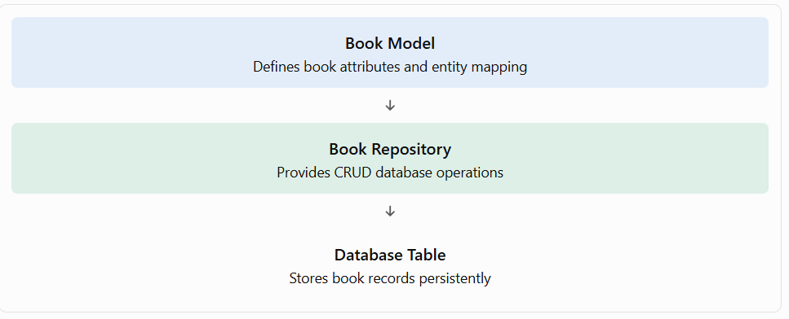When the application needs to store or retrieve a book, the service layer calls the repository. Spring Data JPA uses Hibernate to map the entity to the database table and execute the required operations.
7. Testing and Verification
Open your GitHub Codespaces terminal and execute:
Step 1: Check the project files
ls src/main/java/com/devops/project/model
ls src/main/java/com/devops/project/repository
Step 2: Compile and test the project
mvn clean test
Step 3: Review the repository implementation
sed -n '1,160p' src/main/java/com/devops/project/repository/BookRepository.java
Step 4: Review the Book model
sed -n '1,200p' src/main/java/com/devops/project/model/Book.java
If Maven completes with BUILD SUCCESS, the project compiled and its configured tests passed. This alone does not prove that database CRUD operations were tested successfully.
8. Result
The Book model and repository structure were described for the Spring Boot application. The model defines book data, while the repository provides methods for interacting with the database through Spring Data JPA.
9. Conclusion
The Book model and repository form the data-access foundation of the Book Issue and Return System. JPA entity mapping connects Java objects with database records, while JpaRepository simplifies CRUD operations. This structure supports maintainable development and integration with the service layer.

